**CHEER SOUTH ALL-STARS**

**2021 - 2022**

# Parent Handbook



“Southeast Georgia’s Leading All-Star Program”

*23years strong!*

**Who we are.**

Cheer South All Stars continues to be a leader in All Star Cheer instruction. Established in 1998, we are proud to announce our 23rd Anniversary this year! We have instructed kids all over the country and have won 6 NCA National Championships. We continue to push the boundaries in the industry. We pride ourselves in being trend setters and quality instruction. Welcome to our Panther Family!! Welcome Home!

**What we do.**

It is our mission that each cheerleader will develop socially through practice and competition, physically through hard work, and psychologically through increased self-confidence, self-esteem, and emotional maturity. We continue to place our athletes on collegiate teams that offer scholarships. We continue to be the leader for college cheer placement in this area. This requires a perfect balance of academic preparation in school, time management, and skill preparation in the gym. We continue to provide a big industry name with a small family feel. We pride ourselves on being a family environment and teaching our kids respect, humility, punctuality, good sportsmanship, dedication, commitment, and core values.

**Commitment:**

Commitment starts with the cheerleader and follows through the parent. It is a privilege to be a Cheer South All Star Cheerleader. The success of your team will depend on each individual team member AND parent commitment and dedication to the team. This is not about the individual. We will not tolerate “individual” attitudes. We feel that the member on the back row is just as important as the member on the front. The first tumbling pass is just as needed as the last. Flyers can’t fly without bases. Flyers are no more important than back spots. It takes a TEAM to win. The team will always come first. This sport requires a very high commitment level. Practices may go over at times or practices may be added last minute. Please make sure you and your family are 110% committed.

**Parent Viewing:**

Parents may watch practices from the parent viewing area. At times, it may be necessary for the coaches to close the parent viewing area. We appreciate your cooperation during these times. Parent viewing may be closed during choreography or for a specific amount of time designated by the team coach. This allows us to effectively coach teams without any outside parent distractions. Parent viewing is a privilege. Please do not sit and “gossip” or “assume” in the viewing area. Our best athletes are often left alone for us to coach and mentor. Please do not be a “helicopter parent”. Any questions, comments or concerns about your child’s progression or practice should be taken to your team coach. If needed, a private meeting will be scheduled with the Coach and/or the Gym Owner.

**Team Practices:**

Be on time! Your child will have 2 to 3 team practices per week. Two weekdays and one Sunday every other week starting in September. Additional practices will be added at the coach’s discretion during the heavy competition season. This is typically November through February. There will be additional practices the week and weekend before every competition.

You can miss up to 4 summer practice days in addition to the holidays given. It is important to have each cheerleader at summer practice to allow the kids to bond, the coaches to formulate the routines, and for the teams to progress and prepare for the upcoming season. Unlike other sports, your child’s presence is not only important for gaining and perfecting new skills but also for safety reasons. Vacation forms are in the back of this packet, in the office, and on the website. All vacations MUST have the appropriate form and approval for it to be excused. Vacation forms turned in less than 2 weeks in advance will not be approved. Vacation requests after July 31st will not be approved. Vacation dates will not be approved

the week of a scheduled competition. Vacation requests via phone or text will not be approved. When filling out a School Request, please make sure the coach is present.

Excessive vacations may affect your child’s position on a team.

**Missed or Tardy Practices:**

If you cannot be at practice, it must be personally pre-approved by your coach. If you will be late, out sick, etc.; you must contact your coach. If you are sick, but not contagious, you will be required to come watch practice, so you are aware of any changes made to the routine. You may bring a blanket and pillow and observe any changes. The coach will decide your participation level at practice if an athlete is sick.

Handwritten notes are not an excused absence. If you are continually late, missing numerous practices, or injured long term, you may be dismissed from the team or placed in an alternate position. Either of which will be determined by the coach and/or gym owner. If you are absent during the week of a competition, you may be replaced. When a child misses practice or is injured, it affects the team.

Homework is not an excused absence. Studying for a test is not an excused absence.

Concerts, Birthdays, Anniversaries, School Breaks, and Family trips are not excused absences. School trips that are not documented for a grade are not excused absences.

Outside sports conflicts are not excused absences.

If you are receiving a grade on a school activity you must fill out the absentee form, located in the back of this packet. Forms must be turned into and approved 2 weeks in advance by your coach AND the Gym Owner so changes to the practice schedule can be made if necessary. Absences due to graded events will be approved. The coaches will do everything in their power to work around graded conflicts by moving practice, but it is not promised. Make-up practices may be called so that the team may practice as a whole. In cases of inclement weather, makeup practices will be added as well. The gym manger will decide what weather conditions permit cancelled practices.

**School Sports:**

If you are on a varsity level school cheer team or other sport it is important that you bring a copy of your scheduled practices, events, and coach’s information to your All-Star Coach and Gym Owner. They will attempt to work around any conflicts the best they can. We cannot guarantee that every conflict will be solved. Only varsity competitive conflicts will be considered as a potential reason to miss practice. We will not work around Middle School/JV Sideline cheer conflicts, Basketball

cheer, or other sports during our season. We simply cannot afford to change all of our practice times for other outside sports. Please take note of this policy before trying out for JV, Winter or Spring sports. All Star cheer is a very timely commitment and should be first priority. Please respect our requests.

**Team Placement:**

Athletes will be placed on a team at the discretion of the coaching staff based on their ability and what is needed on each team. It is especially important to understand that quality technique and execution of a skill go into placing teams. It is very important to also understand stunting requirements for each level. It is not only important to “land” a skill, but to execute it while doing so repeatedly. Athletes must also provide strong technical stunting skills at the required level as well. Coaches reserve the right to move a child to a different team during the season if the child’s skills do not mirror that of his or her peers on the team. A child may be dismissed or placed in an alternate position if the skills are not where he or she can be used on a team in the gym. A child may be moved to a different team during the season depending on what is needed by that team (i.e.. base, fly, tumbler), or if their skills are not where they should be during the progression of the season. We may merge teams, change levels, or delete a team during the season. We may register teams in various divisions throughout the season. We will exhaust every possibility before dismissing a team. If you have a question about what level your child should be, please go to USASF.net for level guidelines or our skills board on the wall for tumbling requirements.

**Athlete and or Parent Behavior:**

Your coaches and gym owners are here to work with you. You are expected to show respect and be courteous to your coaches and teammates always. You are not to make negative facial expressions, talk under your breath, roll your eyes, make rude gestures, or negative comments of any kind. When asked a question at a practice, athletes are to reply in a respectful manner to coaches. No negative or rude comments are to be made on any social forum websites such as, Facebook, Twitter, Instagram, Vine, Snapchat, etc. about any member of the CSA teams/staff, competitions or other fellow gyms. Do not post any pictures of yourself or others, in a CSA uniform or attire acting in a negative manner that would discredit the gym’s reputation. No cell phones are allowed during practice or competition warm-ups/awards. Cell phones must be turned in at the beginning of practice to the cell phone basket. Cell phone use during practice is strictly prohibited. Anyone with continued behavioral problems will be removed from the gym and all monies will be forfeited.

**Quitting/Removal from Team:**

**Guidelines for Dismissal**: These are the guideline for dismissal from a team and/or program for athletes and parents. (1). If the athlete obtains a serious injury during pre/post season at practice or a competition. (2). Nonpayment of gym fees, booster fees, etc. (3). Behavior that the coaches/owners feel is unbecoming of a Cheer South All-Star athlete, whether at practice or not. (4). Social Media misconduct including but not limited to Facebook, Twitter, Instagram, Snapchat, YouTube, etc. (5). An athlete may be dismissed due to parental misconduct in the gym and/or at a competition.

**If you quit a team at any time during the season or are asked to leave a team, there will be a quitting fee of $800.** Parents agree that 100% of all monies given to the gym will be forfeited. This includes gym fee, registration, camp deposits, competition deposits, uniform deposits, etc. Any outstanding posted bills up to the date of dismissal will be collected and is responsibility of the athlete, parent and/or guardian. Any outstanding balances not collected will be turned over to a collection agency. The same rule applies for a parent asked to leave the gym for inappropriate behavior/conduct. **(See Financial Contract/Agreement)**

**Practice Wear/Uniform:**

Practice wear will be ordered for the athletes at the start of the season. Once it arrives, athletes will be expected to wear the designated clothing items to their assigned practice times each week. Practice wear will cover all 2 practice days.

These items also will be used during the season and at competitions as well to show unity. Team shirts will be added for larger competitions during the year Uniforms will be ordered in the summer. The cost of the uniform may vary from year to year, or by team specific uniforms. Program warmup jackets will be ordered in the fall. Competition/practice shoes are to be purchased separately. Cheer shoes are required by the first official practice date in August.

**Competitions:**

This is a TEAM Sport. You are required to attend ALL competitions. It is the discretion of the coaches to choose competitions they see best for each of the teams. There is a possibility that a competition may be added or cancelled during the season. If an athlete misses a competition for any reason, he/she may be removed from the team. The team coach/gym owners will keep you informed of all competition updates/changes.

**Hotel/Airfare/Travel:**

We have secured mandatory hotel blocks for all travel competitions.

It is **MANDATORY** for all team members to stay in the assigned team hotel with an adult guardian and must arrive at the hotel during a designated time. Typically, the arrival time is by 9pm. Travel must be planned on Friday. Every team may have

practice the Thursday night before a competition. **DO NOT PLAN TRAVEL ON**

**THURSDAY.** You may not return home until after the last team performs or awards ceremony stated, unless approved by the team coach and/or gym owner. We will not know compete or awards ceremony times until the WEEK of the competition when the schedule is released to us. Please plan accordingly. Transportation is up to each family’s discretion. When you have selected your travel arrangements, please notify your team coach so he/she can verify the arrangements have been made. Once you arrive at the designated Hotel, you must contact your team coach and let him/her know of your arrival and room number. Hotel links will be provided when the competition schedule is released by the gym owner or office staff. Your team may travel for one or more of the competitions listed. Please note that when traveling, you are there for the purpose of competition and not vacation. There will be specific meet times and team functions planned for your child. Their attendance will be mandatory. Please remember that you represent your team, family, and the gym when traveling. Be respectful of others at all times.

**Fees:**

Once selected for a team in April, the first initial payment, see team payment schedule, is due on or before May 1st.Insurance/Medical Fees are Annual and cover our Insurance Calendar year from May-April. Once enrolled, everyone should familiarize themselves with the program website (www.cheer-south.com) and the automated payment website, Studio Director. EVERYONE is required to sign in and create an account on the Studio Director website. Please contact the front office if you have forgotten your login/ password. Please DO NOT create a new/duplicate login/password. If any issues arise, please contact Keyshia or Katina at cheersouthallstars@gmail.com.

Once you have created a parent portal account on Studio Director, you will use this for all classes, teams, etc. This profile will be used to send out mass emails when needed. Please make sure to keep your email, address, and phone number current with the Studio Director parent portal. Also, our accounting system is set up on auto-pay. Your credit card will be billed monthly or biweekly to cover All Inclusive Payments. Fees are late on the 5th of each month. You will get a statement each month with all fees due and their due dates. **Non-auto-pays MUST be pre- approved by the Owners.**

Athletes will be dismissed from the program if fees become delinquent. Athletes may not try out the following year if he/she owes a remaining balance. Athletes may not attend the Banquet if he/she owes a balance. All past due fees will be turned over to collections at the end of the competitive season in April. Any returned checks or late payments will be assessed a charge of $20 or $30 per occurrence.

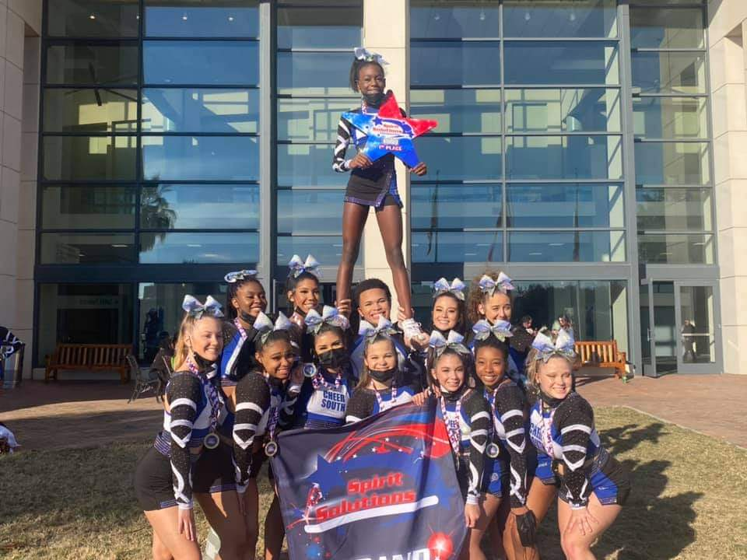*Monthly tuition is set to cover athlete training. All Inclusive Fee payments are set to cover competition registrations, stunt camp, choreography fees/edits, music fees/edits, coaches’ certification, coaches’ registration, and coaches travel. Additional fees may apply if your child’s team attends NCA All-Star Nationals and/or Varsity D2 Summit. Additional fees may be applied if competition registration changes during the season. *Tuition/Gym fees, Insurance/Medical fee, Competition fees, and USASF fee are all non-refundable and must be paid at the Initial Parent Meeting to reserve your child’s placement on a team.

**In the event of natural disaster(s), pandemics, or any other circumstance out of the gyms control:**

In case of any cancellations or non-receipt of competitions, camps, choreography, practices, or any other goods or services due to events or circumstances outside the control of the gym; the gym will ONLY reimburse or credit customers for the amount of fees paid to the gym that are cancelled or refunded by vendors, minus any directly related gym labor and administrative expenses. In any of the above circumstances, the gym is not responsible for payments made to vendors or other providers that are not refunded, whether those payments were made through the gym or directly from the customer to the vendor.

**Demerit System:**

New this year Cheer South will implement a Demerit System to hold athletes/parents accountable for their actions during Season 23. Demerits will be giving for breaking the rules. When a demerit is given, the coach will give the athlete a copy of the write up for their parents to see. A copy will go to the Office Manager to keep a running total for the month and season for each athlete. The goal of the demerit system is for athletes to make it into the “ZERO Demerit Club”. The “ZERO Demerit Club” is an incentive to NOT earn demerits. It will take the place of the “ZERO Balance Club”. At the end of each month, any athlete that has not been given a demerit that month (even though demerits will accumulate throughout the entire season) will be able to attend the “ZERO Demerit Party the last 15 minutes of practice on the last practice of the month. An Event Committee will be put in place to handle team celebrations. Each team will have a parent representative on the committee. They will be responsible for planning and implementing their team’s celebration. These do not have to be big or expensive. It can be anything from a snack, playing games and or free time on the tumble Trak/ air Trak. The athletes who are unable to attend their team’s celebration will continue with practice/conditioning the last 15 minutes of practice with one of the coaches.

**Demerit Consequences** (Demerits accumulate over the season)

* **5 Demerits- Written letter from the coach or gym owner to the parent**
* **10 Demerits- Meeting between the parents, athlete, coach and gym owner.**
* **15 Demerits- Dismissal from the team/Program**

**Reasons for Demerits:**

|  |  |
| --- | --- |
| 1. Demerit | * Wearing incorrect practice wear * Tardy to practice (15 minutes) * Miss more than 4 Summer practices * Miss practice when sick but **NOT** contagious * Miss practice for **ANY** reason without informing a coach or gym owner * Athlete displays any inappropriate behavior as outlined in the Athlete Behavior Section of the Handbook. * Using cell phones during practice without approval from a coach * Leaving competition early **WITH** prior approval by **Keyshia or Katina ONLY** * Removal of a credit card on Studio Director * Disabling Auto-Draft on Studio Director |
| 2 Demerits | * Miss practice for vacations **without** prior approval using Vacation Form * Miss practice the week of a competition unless contagious * Arrive at competition 10-15 minutes late after the arrival time set by the coach. * Wrong or inappropriate attire at competition (ex. Bra straps that show, pajama pants, crocs, and UGGS while at competition. Missing other teams’ performance, missing part of uniform, hair and makeup different from what coach required. * Leave competition before ALL CSA teams have competed **without** prior approval from Keyshia and or Katina ONLY. |
| 3 Demerits | * Delinquent accounts not paid off by the 5th of the month. * Leave a competition before your team’s awards * Not staying at assigned hotel when it is mandatory |
| Reasons for **IMMEDIATE** dismissal from the team per handbook | * Failure to attend competition * Injured long term resulting in an inability to perform the routine (3 months or more) * Any misconduct or inappropriate behavior of an athletes or parent including social media misconduct (see handbook for details) * Earning 15 demerits |

**Loyal Legacy Reward Program:**

This program is a **FREE** way to reward families who are dedicated and loyal to CSA. Below are the terms.

* Athletes are eligible for this incentive ONLY if they were enrolled in CSA the previous season and paid ALL payments on time with no late fees.
* Athletes are INELIGIBLE for the Loyal Legacy Reward Program if they were not enrolled in CSA the previous season and or had a delinquent account resulting in a late fee the previous season.
* Reward: If you have completed the program 1-3 years you get a Punch Card for 4 FREE Team Tumbling Classes. If you have completed the program 4-6 years you get a Punch Card for 8 FREE Team Tumbling Classes. If you have completed the program 7-9 years you get a Punch Card for 12 FREE Team Tumbling Classes. If you have completed the program 10+ years you get a Punch Card for 20 FREE Team Tumbling Classes.
* New this year Cheer South will implement a Demerit System to hold athletes/parents accountable for their actions during Season 23. Demerits will be giving for breaking the rules. When a demerit is given, the coach will give the athlete a copy of the write up for their parents to see. A copy will go to the Office Manager to keep a running total for the month and season for each athlete. The goal of the demerit system is for athletes to make it into the “ZERO Demerit Club”.

**Pay in Full Incentive:**

If Tuition is **paid in full for the season** on or before May 1st, 2020, we will extend one of the following incentives to the athlete/parent.

* Choice A: $75 Pro Shop Credit for Elite Teams, $50 Pro Shop Credit for Novice & Prep Teams or
* Choice B: A punch card for 8 FREE Team Tumbling Classes for Elite, 5 for Novice & Prep Teams

**End of Year Banquet:**

Cheer South All-Stars End of the Year Banquet is always one to be remembered. It is held at the end of each season. Sunday best or semiformal dress is requested. The banquet is a catered event and will require you to purchase tickets in advance. Information will be available near the end of the season, but this is an event that you won’t want to miss. We will present end of year awards for each team, watch year review slideshows, and crown a new Cheerleader of the Year!

Welcome to OUR Family!!

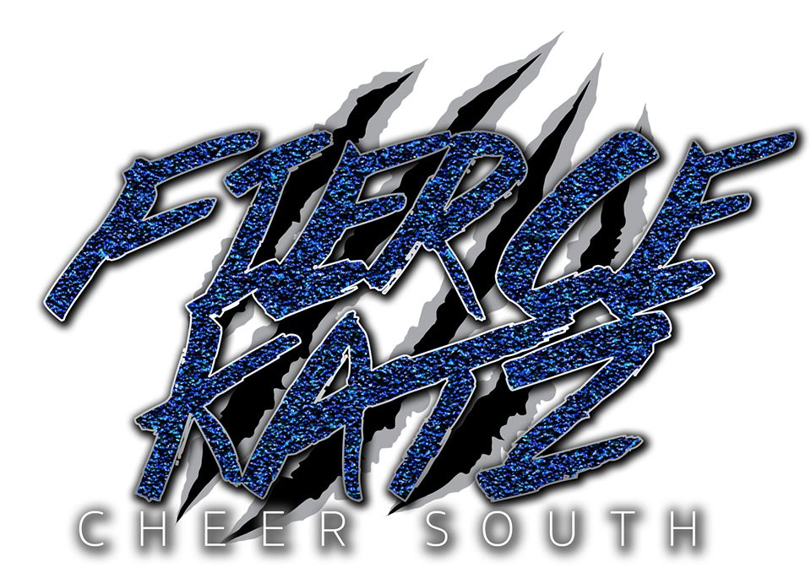



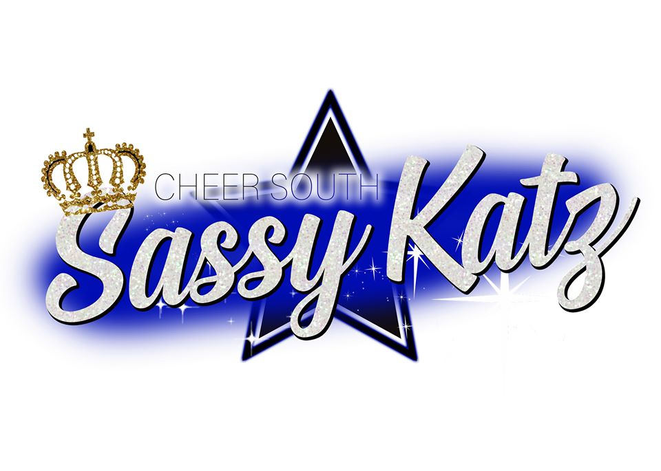

Welcome Home!

**#CHEERSOUTH #PANTHERS #BLUEBLACK&White #NOW&FOREVER #23YEARS #SEASON23**